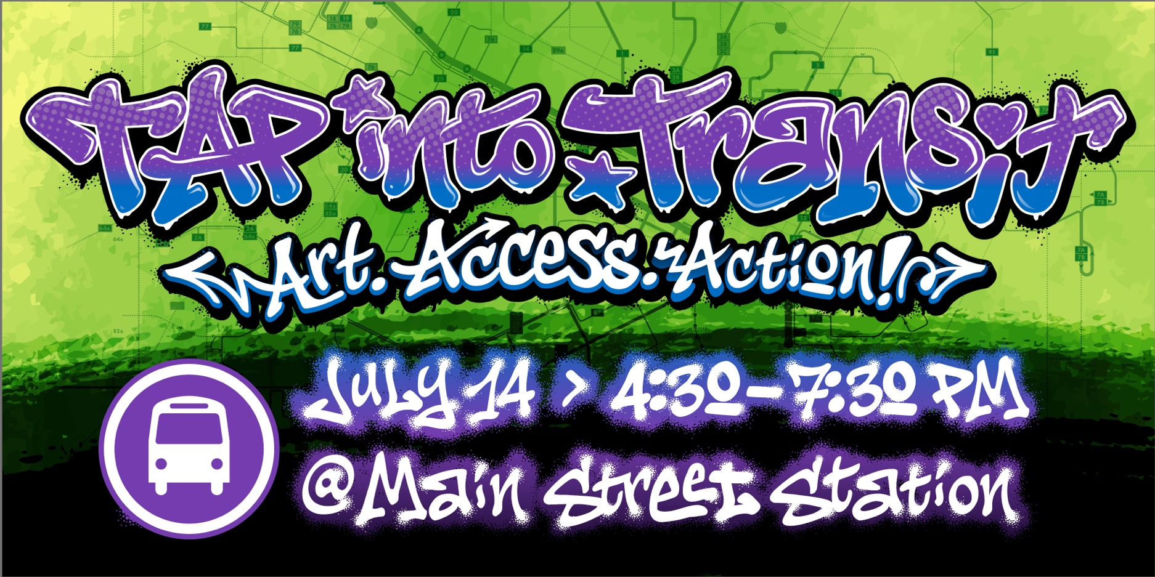

TAP Into Transit Day Returns July 14
Join regional transit partners, and community members for TAP Into Transit Day, a community fundraiser supporting the future of Open Access transit in the Richmond region.
This year’s event will bring together riders, local organizations, artists, advocates, and regional leaders to celebrate the impact of public transportation and help support fare free transit access through the Transit Access Partnership (TAP).
The event will feature a curated art installation led by Richmond artist Silly Genius, All City & friends, alongside interactive experiences, community partners, and opportunities to learn more about the future of transit in our region.
Open Access transit means everyone can ride with no fare and no barriers, helping connect people to jobs, healthcare, education, and everyday opportunities.
When: July 14, 2026 | 4:30 – 7:30PM
Where: Main Street Station
Tickets: Free to attend
Learn more and RSVP here: https://www.ridegrtc.com/community/tap-into-transit/

