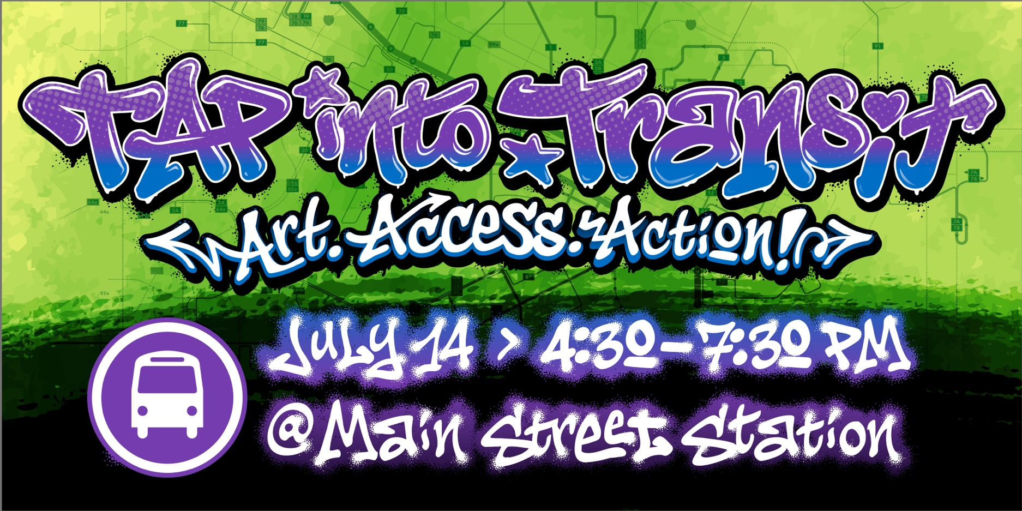
TAP Into Transit Day: July 14, 2026 | Main Street Station | 4:30 – 7:30PM
What is TAP Into Transit Day?
A community fundraiser supporting the future of Open Access transit in the Richmond region.
What does Open Access transit mean?
A transit network where everyone can ride with no fare and no barriers.
Who is the event for?
Riders, donors, community organizations, regional leaders, artists, advocates, and supporters who believe in the impact of public transportation across the region.
What are funds used for?
Funds raised through the Transit Access Partnership (TAP) help support the long-term sustainment of Open Access transit and connect people to jobs, healthcare, education, and everyday opportunities.
What’s new this year?
A curated art installation led by Richmond artist Silly Genius, All City & friends.
Why do partnerships matter?
Regional partnerships help strengthen awareness around Open Access transit and expand access to opportunity throughout the Richmond region.
How can partners support the event?
Attend, sponsor, share the event with your networks, and help grow support for Open Access transit.

