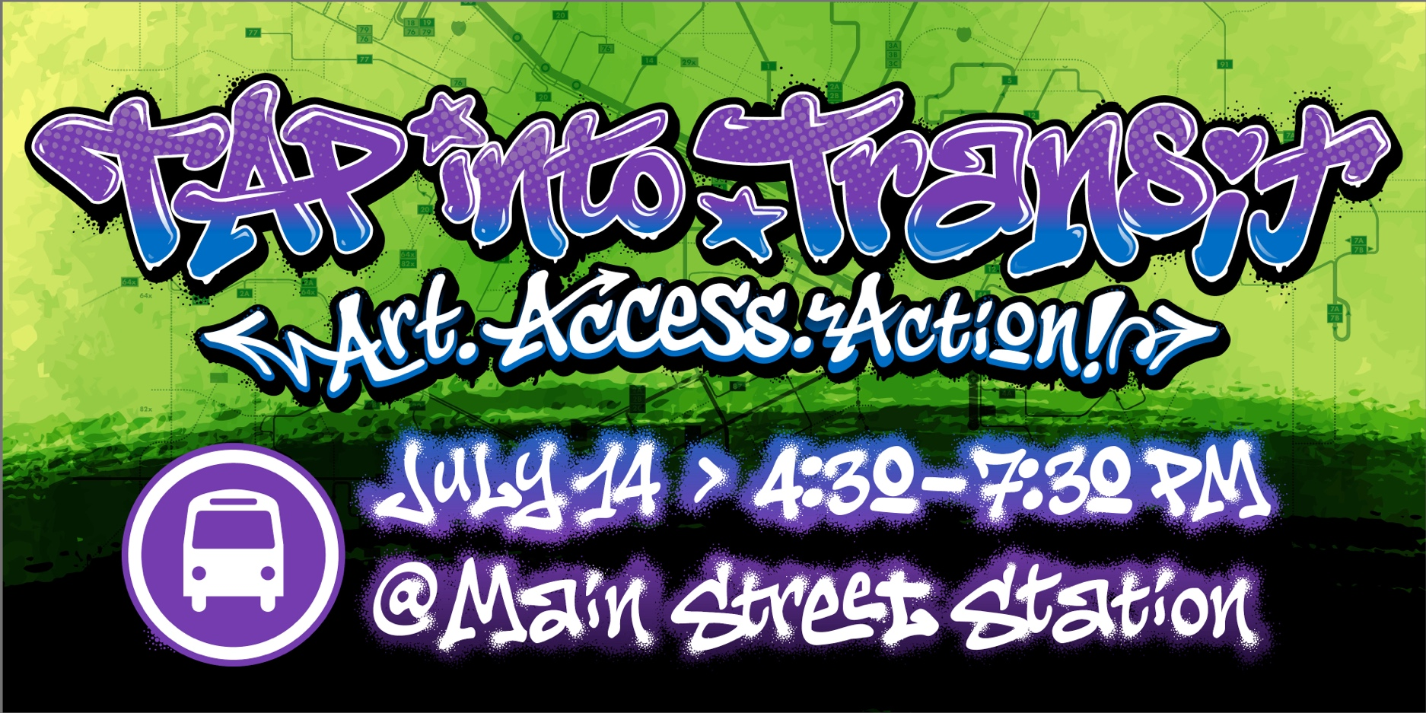
TAP Into Transit Day: July 14, 2026 | Main Street Station | 4:30 – 7:30PM
• TAP Into Transit Day serves as a community fundraiser supporting the future of Open Access transit in the Richmond region.
• Open Access transit means a transit network where everyone can ride with no fare and no barriers, helping connect people to jobs, healthcare, education, and everyday opportunities across the region.
• GRTC provided more than 12 million trips last year, with ridership growing by more than 4 million annual trips since FY21 as demand for reliable and accessible public transportation continues to increase across the region.

• GRTC connects riders to more than 230,000 jobs across the Richmond region, helping strengthen workforce access, economic mobility, and regional connectivity.

• The conversation around Open Access transit is really about long term sustainability. Ridership continues to grow, and regional partnerships will help shape the future of transit accessibility and mobility in Central Virginia.

• TAP Into Transit Day will bring together riders, donors, community organizations, regional leaders, artists, advocates, and supporters who believe in the impact public transportation has on the region.

• Funds raised through the Transit Access Partnership (TAP) help support the long term sustainment of Open Access transit and strengthen access to opportunity throughout the Richmond region.

• This year’s event will feature a curated art installation led by Richmond artist Silly Genius, All City & friends, highlighting the connection between transit, community, and culture in the region.

• Regional partnerships play an important role in helping expand awareness around Open Access transit and building long term support for a more connected and accessible region.

